CRUISE CONTROL

software requirements

Authors Frederic BESSIERE

Last Update August 22nd, 2007

Summary:

This document defines requirements of a cruise control system for an automatic transmission car.

Table Of Contents

1. Introduction 3
2. Cruise Control Requirements 3
2.1 Interface 3
2.2 Cruise Control behavior 4
2.3 Car driving control 5
2.4 Cruise speed management 5
2.5 Pedals pressed detection 6
2.6 Cruise Control parameters 6

Introduction
The Cruise control is a system to automatically control the speed of a car. The driver sets the speed and the system will take over the throttle of the car to maintain the same speed.

Cruise Control Requirements

Interface

The Cruise Control (CC) should connect to the system using the following inputs.

CC_HLR_IN_01
On: Enable the CC

CC_HLR_IN_02
Off: Disable the CC

CC_HLR_IN_03
Resume: Resume the CC after a braking

CC_HLR_IN_04
Set: Set the current speed as the new cruise speed

CC_HLR_IN_05
QuickDecel: Decrease the cruise speed

CC_HLR_IN_06
QuickAccel: Increase the cruise speed

CC_HLR_IN_07
Accel: Accelerator pedal sensor

CC_HLR_IN_08
Brake: Brake pedal sensor

CC_HLR_IN_09
Speed: Car speed sensor

And the CC should deliver the followings outputs.

CC_HLR_OUT_01
CruiseSpeed: Cruise speed value

CC_HLR_OUT_02
ThrottleCmd: Throttle command

CC_HLR_OUT_03
CruiseState: this is the state of the CC. It can be OFF, ON, STDBY, INT.

The following diagram resumes the CC interface:

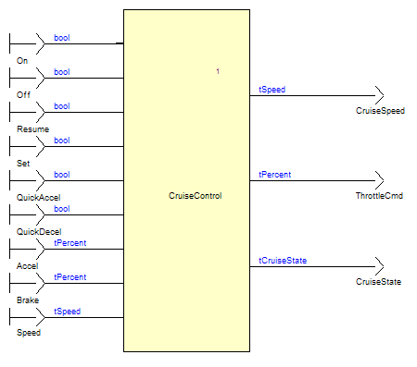

Cruise Control behavior

CC_HLR_CCB_01
When the driver starts the car, the CC shall be off.
The output CruiseState should be set to OFF

CC_HLR_CCB_02
The CC shall be set on when the driver push the on button.

CC_HLR_CCB_03
The CC shall automatically go off when the off button is pressed.

CC_HLR_CCB_04
If the car speed is in the speed limit and the accelerator pedal is not pressed, the CC shall be on and regulate the car speed.
The output CruiseState shall be set to ON.

CC_HLR_CCB_05
The CC system shall be automatically disabled when the accelerator pedal is pressed, or the car speed is outside the speed limit.
The output CruiseState shall be set to STDBY.

CC_HLR_CCB_06
The system shall return to the ON state when both the accelerator pedal is not pressed, and the car speed is inside the speed limit.
The last set cruise speed shall be re-used.

CC_HLR_CCB_07
The CC shall be immediately interrupted when the brake is pressed.
The output CruiseState shall be set to INT.

CC_HLR_CCB_08
The system shall resume either to the ON or STDBY states, depending on the Accelerator pedal and the Speed value when the resume button is pressed. The last set cruise speed shall be re-used.

Car driving control

CC_HLR_CDC_01
When the CC is off, the car speed shall be driven using the accelerator pedal.

CC_HLR_CDC_02
When the CC is on, the car speed shall be automatically regulated.

CC_HLR_CDC_03
The regulation shall be done using a proportional and integral algorithm, with Kp and Ki factors.

CC_HLR_CDC_04
The regulation algorithm shall be protected against the overshoot of its integral part: the integral action shall be reset when the CC is going on, and frozen when the throttle output is saturated.

CC_HLR_CDC_05
The throttle command shall be saturated at ThrottleSatMax when automatically regulating, in order to limit the car acceleration for the comfort.

Cruise speed management

CC_HLR_CSM_01
The Cruise Speed shall be managed only when the cruise control is enabled, meaning ON, STDBY, or INT states.

CC_HLR_CSM_02
The cruise speed shall be set to the current speed when the set button is pressed.

CC_HLR_CSM_03
The cruise speed shall be increased of SpeedInc km/h when the QUICKACCEL button is pressed.
only if this new value of the cruise speed is still lower than the maximal speed SpeedMax km/h.

CC_HLR_CSM_04
The cruise speed shall be decreased of SpeedInc km/h when the QUICKDECEL button is pressed.

CC_HLR_CSM_05
The Cruise Speed shall be maintained between SpeedMin and SpeedMax km/h values.

Pedals pressed detection

CC_HLR_PPD_01
The accelerator pedal shall be detected as pressed when its value is above PedalsMin.

CC_HLR_PPD_02
The Brake pedal shall be detected as pressed when its value is above PedalsMin.

Cruise Control parameters

CC_HLR_CCP_01
SpeedMin: 30.0 Km/h

CC_HLR_CCP_02
SpeedMax: 150.0 Km/h

CC_HLR_CCP_03
SpeedInc: 2.5 Km/h

CC_HLR_CCP_04
Kp: 8.113

CC_HLR_CCP_05
Ki: 0.5

CC_HLR_CCP_06
ThrottleSatMax: 45.0 percent

CC_HLR_CCP_07
PedalsMin: 3.0 percent.

